Instructions for Returning Spring 2021 ACCESS and Alternate ACCESS Test Materials

The Florida Department of Education has extended the ACCESS for ELLs and Alternate ACCESS for ELLs testing window to Friday, May 28, 2021

Deadline for Returning Test Materials
The deadline for schools to return all ACCESS and Alternate ACCESS test materials is Friday, June 4, 2021.
- Schools that complete testing early are encouraged to return their test materials as soon as testing is finished at your school.
- Schools will make their own arrangements to return their test materials via UPS. See instructions on page 2.
Packing Instructions
For detailed packing and returning instructions, please refer to the Spring 2021 Florida ACCESS for ELLs Test Administration Manual beginning on page 57.

The table below outlines the materials to include and not to include in your return shipment:
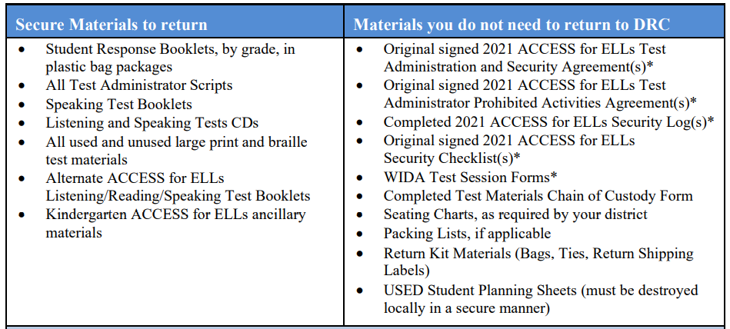
*Items with an asterisk must be destroyed in a secure manner after scores are reported.

Box Materials for Return
- Use the boxes from your original shipment to box materials for return. If a box is damaged or lost, you may substitute a box of similar size and strength.
- Place all materials within the plastic DRC return bags and seal each bag with a zip tie. If you do not have bags or run out of bags, just place the materials directly into the boxes.
- All materials (used and unused, manuals and test books) can be placed in any box. Alternate ACCESS for ELLs and Kindergarten ACCESS for ELLs materials may be mixed with ACCESS for ELLs materials. Condense boxes whenever possible.
- Unused student labels should be discarded at the school. Do not box them for be return.
- Fill any empty space in the box with crumpled paper or bubble wrap to ensure that materials do not shift during transit.
- Fold the box flaps with the old shipping labels first to expose the unused flaps.
- Affix both a DRC orange return label and a UPS shipping label to each box and securely seal the boxes using heavy duty shipping tape.
Ship Boxes via UPS
- You may drop off your boxes at any UPS Store.
- If your school does not have a regularly scheduled UPS pickup, you must call UPS to
arrange for a pickup at least one day prior to the day you plan to return your materials. Do not call your local UPS Store to pick up your boxes. You must call the UPS number at (866) 857-1501.
- Count your boxes and advise UPS of the number of boxes you have for pick up.
- Keep the boxes in a secure location until they are given to the UPS driver. You should not be asked for any payment.
- Keep the UPS tracking numbers for all boxes. You will need the tracking numbers to complete the Return Confirmation Form for ACCESS for ELLs and Alternate Access For ELLs.
Contact Student Assessment and Research at 754 321 2500 if you have any questions.

